# Civil rights

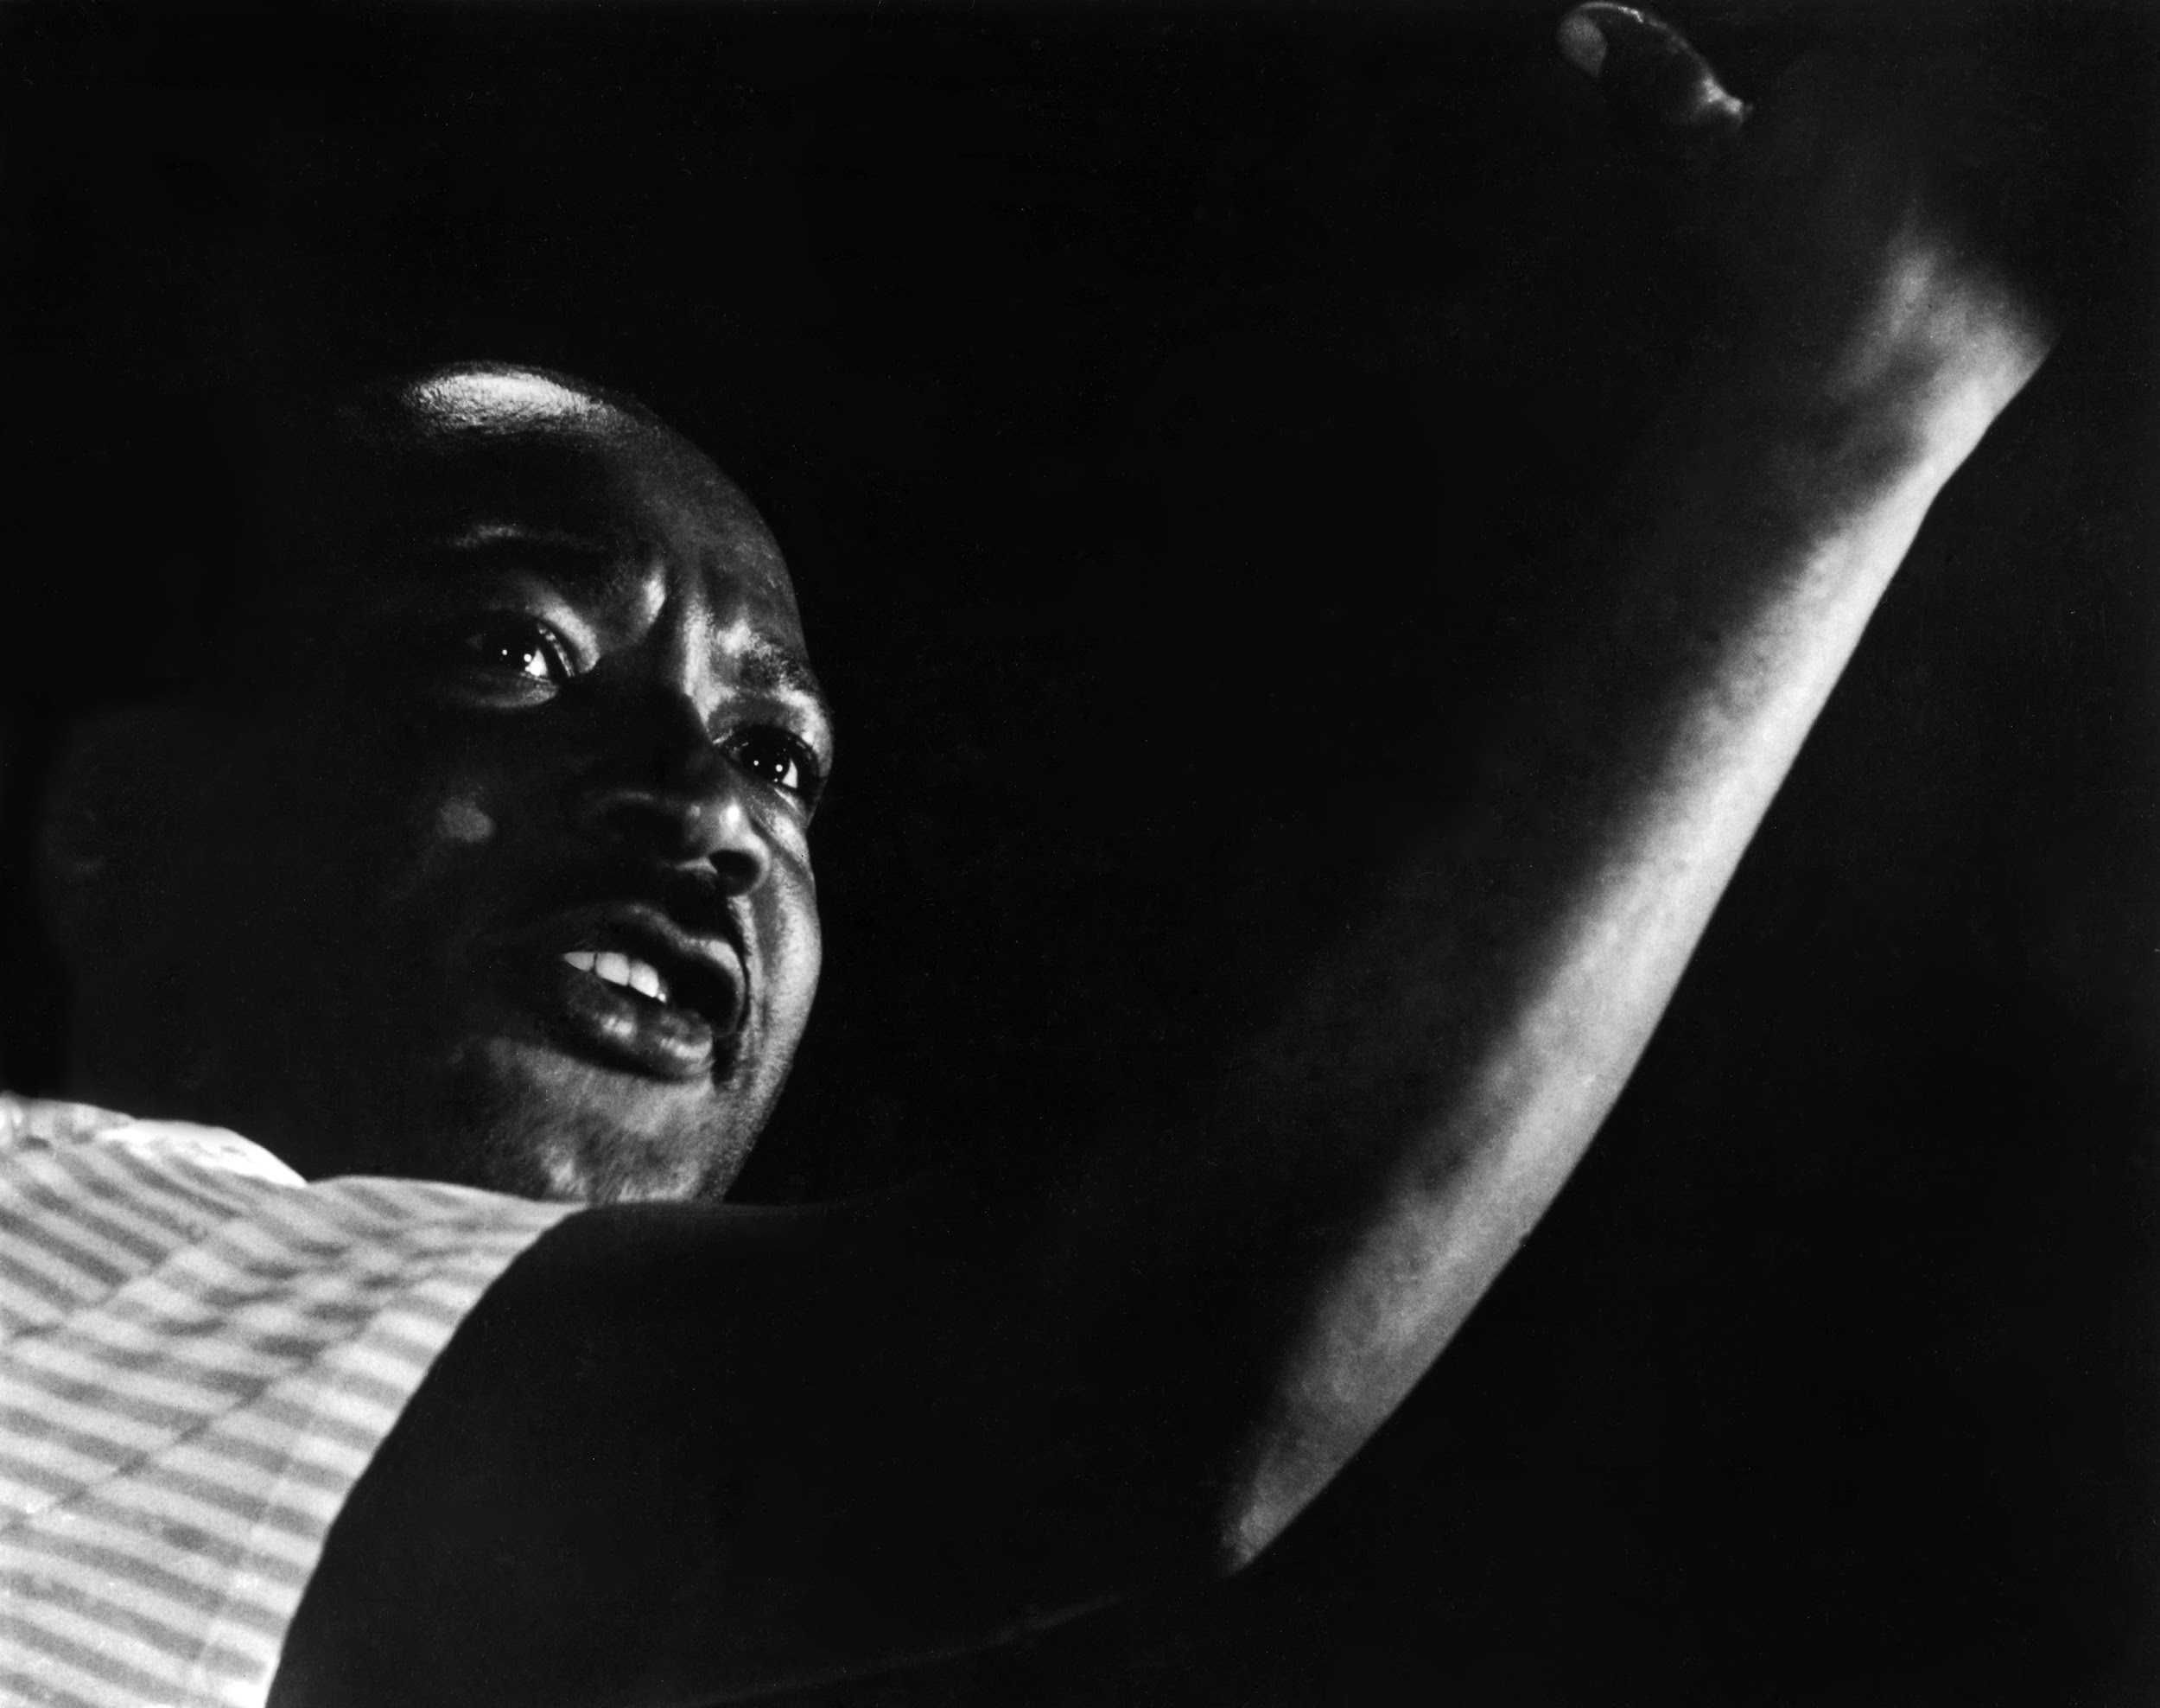

## Composition

This photo makes nice use of thirds with King's face positioned in the left third. The photo is shot from slightly below King, which adds an air of authority and importance to his figure. The photo is tightly framed so that King's arm fills the rest of the image.

## Lighting

King is lit only from the side, which creates lovely shadows across his skin and allows the left sides of his features to fade almost entirely into the background. The background behind him is completely featureless negative space and brings your focus directly to King's face. The image of King's face as the lone light in a sea of darkness is quite moving.

## Moment

Catching King with a perfect facial expression and his fist raised just right so that it fills the frame nicely is a great feat. While this is not Benson's most impressive example of capturing the perfect moment, it is quite a well-timed shot.

## Value

This is a fantastic photo of an important civil rights leader. This captures King's strongly held beliefs but also hints at his well-mannered demeanor and his unwillingness to resort to violence. He is raising his fist, but his face is not filled with rage, instead inspiring hope. This photo matches very well with my mental image of King's character and persona.

# Pop culture

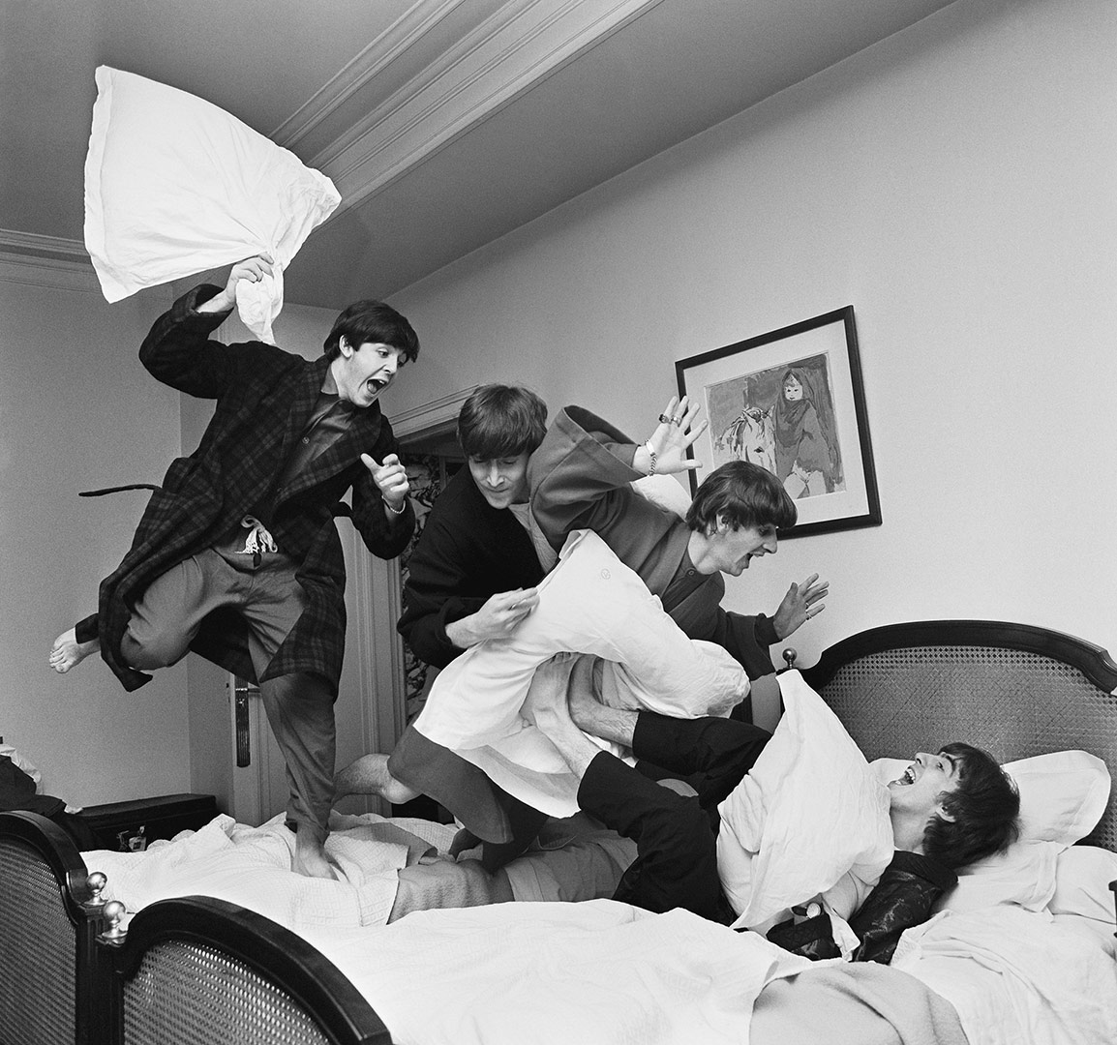

## Composition

This photo is a fantastic example of leading lines. There is a very natural line of action from top-left to bottom-right, going from the raised pillow all the way to the bed. Your eyes travel along this line repeatedly as you pick up on all the details of the photo. Overall it's generally well framed, as all the action fits nicely into a square image.

## Lighting

The photo is well-lit and brighter despite being in a hotel room, which are often quite dim. It seems that Benson may have brought in lights – the shadows on the wall in the background suggest the light is coming in from behind Benson rather than from ceiling lights. The bright pillows and sheets contrast with the mostly dark clothing and hair of the Beatles.

## Moment

This photo is a quintessential example of capturing the moment. There were so many factors that had to line up here: everyone had to have their face visible, eyes open, and making an interesting expression, several interesting-looking pillow attacks had to occur simultaneously, and the line of action had to naturally form out of all of this. This is not a moment you could have drawn up or planned for, and could only come from being in the right place at the right time, being diligent and having a good bit of luck.

## Value

*Time* included this photo in their 100 Photos collection of significant photos, and I tend to agree with their decision. This is an infamous depiction of the Beatles and their popular image of silliness at the time of their American invasion. When I saw "pop culture" on the list of topics for this response, I knew immediately that I had to write about this photo. In my opinion this is one of the most significant photos of the most significant bands of the 20th century.

# Politics

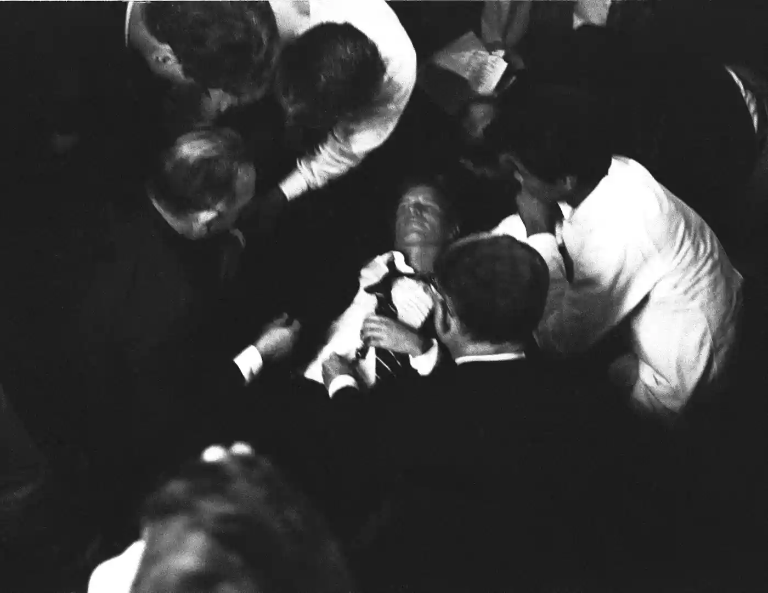

## Composition

This photo is very impressively composed and is a great example of framing with form. Your attention is immediately drawn to the wounded Bobby Kennedy in the middle of all the campaign staff rushing to his aid.

## Lighting

This photo is quite dark, containing huge swaths of pure blackness with no discernible features. While this is usually an undesirable effect, it is rather fitting for a photo of an assassination and adds an air of grimness to the photo. Most of the photo is bright whites or dark blacks, but the most important part, Kennedy's face, is well-balanced in the middle and can be made out fairly clearly.

## Moment

This is an irreplaceable photo of a horrific and significant moment in history. At this point in time, the gunman had presumably not be apprehended yet and Benson couldn't have known if he was even safe yet. Nonetheless, he kept his composure and shot a very well-made image.

## Value

This photo is hugely important for its role in making the assassination feel visceral. It's one thing to hear that a well-known senator and a frontrunner for the presidential race has been shot, but to see the moment he passed away brings the horror front and center. While some might wonder if Benson should have tried to help instead of photographing, I think that there is little he could have done to save Kennedy, and that memorializing the moment was the most valuable thing he could have done.